roid

217, Sheikh Rashid Building

P.O Box 56272, Dubai

United Arab Emirates

Tel: +971 4 2973236

Email: uae@verbat.com

TECHNICAL  
PROPOSAL

**SCTDA Licensing and Classification System [TSD/01/2018]**

|  |  |
| --- | --- |
| **Prepared for:**  **Sharjah Tourism and Commerce**  **Development Authority** | **Submission Date:**  11 June 2018  **Proposal ID:** AD/TP/11062018/1830/1 |

___________________________________________________________________________________________________________________________________________  
Conﬁdentiality Notice: This Proposal is conﬁdential and contains proprietary information and intellectual property of Verbanet Technologies LLC. Neither this proposal nor any of the information contained herein may be reproduced or disclosed under any circumstances without the express written permission of Verbanet.

© 2018 by Verbanet Technologies LLC. All rights reserved. Confidential.

___________________________________________________________________________________________________________________________________________

Project Contacts

|  |  |
| --- | --- |
| Client Information | |
| Project Name | SCTDA Licensing and Classification System |
| Client Name | Sharjah Tourism and Commerce  Development Authority |
| Client Address | Crescent Tower, Al Buhaira  P.O. Box: 26661, Sharjah - U.A.E. |
| Contact Person | Ms. Muna Fairouz Al Resheq  Executive – Contract & Procurement Division |
| Contact Person Email | Muna.r@sharjahtourism.ae |
| Contact Person Phone Number | +971 6 556 6777 |
| Verbat Information | |
| Contact Person | Ms. Simi Soosan Thomas |
| Contact Person Phone Number | +971 4 2973236 Ext:103 |
| Contact Person E-Mail | [simi.thomas@verbat.com](mailto:simi.thomas@verbat.com) |
| Address | PO Box 56272, Dubai, United Arab Emirates |
| Physical Address | 217, Sheikh Rasheed Building, Hor Al Anz East |
| Project Information | |
| Proposed Technology/Methodology | C#, MSSQL, MVC, CSS, JQUERY, HTML |
| Anticipate Start Date | NA |
| Proposal Valid For | 90 Calendar days from the submission of the proposal |

**Table of Content**

1 Executive Summary 5

1.1 Proposed Solution Model 6

1.2 Solution Objective 6

1.3 Advantages of Proposed Solution 7

1.4 Why Verbat 8

1.5 Key Differentiators 9

1.6 Verbat’s Technology & Services 10

2 Functional Specifications 11

3 Nonfunctional Requirement (Others) 14

4 Assumptions 15

5 Out of Scope 17

6 Technology Solution 18

6.1 Proposed System Environment 18

6.2 Technical Configurations 19

6.2.1 Development Tools 19

6.2.2 Suggested Web Hosting Specification 19

6.2.3 Browser Compatibility 19

6.2.4 Hardware Interface 19

6.2.5 Technical Standards 20

6.2.6 Technical Guidelines 20

7 Delivery Management 21

7.1 Project Management 21

7.2 Roles and Responsibilities 21

7.3 Delivery Activity Summary 21

7.4 Project Implementation Plan 22

7.5 Deliverables 22

7.6 Estimated Delivery Time 23

7.7 Deployment Details (at Clients Behest) 24

7.8 Release Planning 24

7.9 Risk and Contingency Planning 24

8 Change Management 26

9 Miscellaneous 27

9.1 Acceptance Criteria 27

9.2 Warranty 27

9.3 General Terms and Conditions 27

9.4 Assumptions and Dependencies 29

9.5 Source Code & Intellectual Property Rights 29

9.6 Maintenance & Support 30

9.7 Service Level Agreement 31

10 Our Clients 32

# Executive Summary

**Sharjah Commerce and Tourism Development Authority (SCTDA)** (Hereafter referred to as the “Client”) was established in 1996 by virtue of the Emiri Decree No. (5), with the objective of promoting commercial and tourism activities in the Emirate. The Authority endeavors to develop these sectors through various events, activities and issuances, and promotes the emirate at all local, regional and international levels.

The Authority carries out all the work and activities necessary to achieve their goals by way of planning and drawing up strategic plans to further development and to promote the tourism industry in all its forms; in addition to conducting related social and economic studies. It compiles the policies for participating in the local, regional and international exhibitions. The Authority also aims at marketing and promoting Sharjah to attract foreign investment.

Verbat is a Digital Technology Services company with over 18+ years of experience in delivering Internet and Mobile Solutions to Enterprises, through Agile Development and Application Management methodologies. Application Development is an area where Verbat has in-depth knowledge and expertise. Being the pioneers in Web based solution across the major verticals, we are sure to help customers drive differentiation. We bring proven methodologies and processes, global expertise in application development, and a legacy of best practices & ready-to-fit frameworks to expedite the development cycle in order to reduce the total cost of ownership.

**SCTDA** (here after referred to as “Client”), has requested **Verbanet Technologies** **LLC.**, trading as Verbat Technologies (hereafter referred as” Verbat”) to develop a Web application and IOS application that can be used for managing the Tourism licensing, classifications, inspections, and fines to the hotels, hotels apartments, and tour operators in the Emirate of Sharjah.

Verbat is pleased to submit the proposal and values it as a great opportunity to have a long term & mutually beneficial association with the Client. Verbat has gone through the requirement and presents a proposal for the requested system.

## Proposed Solution Model

**Stand-Alone Fixed Bid or Managed Solution Model**

Verbat will be following a stand–alone fixed bid or Managed solution delivery model wherein the required solution would be devised and a suitable pricing would be offered.

## Objectives of Licensing and Classification Services (LCS)

The primary purpose of the application is as follows:

* To provide a one-stop gateway to perform a multifunction licensing, classification, inspections, and fines processing and transactions as detailed in the Solution Objective section (Annexure A, B, and C).
* To reduce the processing time and to create a Solution structure to efficiently regulate and control the entry and management of licensing, classifications, inspections, and fines to the hotels, hotel apartments, and tour operators in the Emirate of Sharjah.

Verbat’s Solution architects have conducted a thorough research on the requirements and have come to the conclusion that our proposed solution, which is detailed further in this document, will meet the requirements put forth by the client. And the proposed solution will be delivered as per Verbat’s proposed solution models.

**Strong and Scalable platform:** The platform proposed will be strong and scalable enough to accommodate future enhancements.

**Accelerated solution:** The framework would act as a solution accelerator. It would provide the basic building blocks which could be reused in future for building new components and features.

**High performance:** The light weight framework used consumes fewer system resources thereby making the application perform faster.

**Security:** The application will be developed considering various aspects of security.

## Advantages of Proposed Solution



01

Agile development offering reliable, secure solution

02

Smooth transition and quicker completion of processes

03

User friendly interfaces enabling easy navigation between screens

## Why Verbat

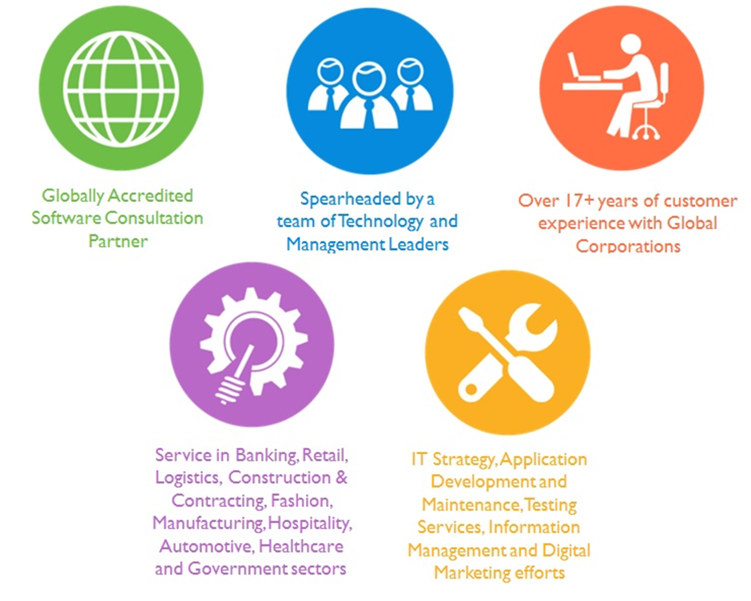

Over 18+ years of customer Experience with Global Corporations

## Key Differentiators

Delivered digital transformation expertise to global customers for over a decade by following industry best practices to maximize ROI for client

Keen technology intelligence combined with aggressive market research to deliver solutions that achieve results with measurable value

Enable access to global consulting expertise with strong local market and business knowledge

Commercial Model that is customizable for your business needs

Services that are designed to optimize applications for improved performance and overall efficiency

1,000,000 plus man-hours of expertise in technology frameworks spanning Microsoft, Open Source, mobility platforms and other proprietary IT technology

Partners top technology vendors to bring in the latest and best services in integration, collaboration, and development

Commercial Model that is customizable for your business needs

Proven Methodologies & Processes

Investment in R & D

Strong Local Presence

Flexible commercial Models

Technology Associations

Software Development Experience

Offshore Development Centre

Quality Assurance & Testing

## Verbat’s Technology & Services



Technology  
&  
Services

Cloud/Traditional Hosting

User Interface & Design

Digital Marketing

Mobility Solutions

Testing Services

Application  
Development

# Scope of Work

The scope of work is to provide a comprehensive solution that is hosted in SCTDA data center to automate all the transactions of the specified services mentioned in the Solution Objective (Annexure A, B, and C) to achieve the objectives of the Project.

The services and workflows mentioned in the Annexures are high level and they don’t specify the detailed workflow. Verbat will collect the detailed transactions, workflow, fields, and conditions etc. and document them in the Software Requirement Specifications (SRS). Verbat will execute the project after getting approval from SCTDA.

* The provided Solution will support different kinds of workflows (registration, application/service, inspection, acceptance, rejection).
* The solution will have different kind of communication channels like SMS and email.
* The solution will currently be integrated with the “Tahseel Payment Gateway” to enable the customers to pay the service fees & issued fines by SCTDA inspector.
* The solution will enable the external customers to register themselves to avail the services offered.
* The interface of the provided solution will be built in HTML 5 responsive design.
* The letters, licenses and receipts issued by LCS will be digitally signed by having a

Reference code/QR/barcode that can be searched by anyone later to check the validity/authority.

* Verbat will work with SCTDA to define the format of the letters, receipts, reports, and licenses.
* The inspection app will be developed as an iOS app (iPad) to be used by the inspectors to perform the inspections.
* The IOS app used by inspectors shall have the ability to work offline when the internet connection is not available, that will assure the availability of the necessary information for the smooth functioning of inspection and fine issuance process.

On the offline mode there will be a limited data saved on the device and ready to be used by the app/ inspector. In addition, the fine issuance process can be done on offline mode as well as online mode. The offline data will be sync with the server whenever the internet connection is available.

* The solution will provide predefined Reports that will serve the several department objectives.
* The solution will be equipped to be integrated with third party BI tools to enable the users to create different type of reports as needed.
* The solution will be designed in a way that allows seamless integration with third party systems.
* The solution will have several type of data flows (IN/OUT) with existing systems like
  + Master Data from Vehicle Permit Issuance system
  + Hotel name, type, rank, category, rooms and access credentials from Hotel Statistics system
* The solution will be integrated with Empost system for signboard delivery (classification) and tour guide license card.
* The solution will have intelligence built into it that can identify hotel/hotel apartments with near expiry licenses. The system will issue appropriate alerts, mails and SMS messages to the concerned. System can automatically disable access to accounts that expired or cancelled their application.

## Key Platform Stakeholders / “Actors”

1. **Applicants:** External users who belongs to hotel, hotel apartments, tour operator and tour guides.
2. **TSD Staff (Licensing staff):**  Users who are working on SCTDA office and their key activity is to verify the documents/requests raised by applicants.
3. **Licensing Head:** User who is working on SCTDA office and his key activity is to review the licensing operations and to recommend approval/rejection whenever applicable.
4. **TSD Manager:** User who is working on SCTDA office and his key activity is to provide approvals at various stages of the workflows and to monitor the entire licensing and classification operations.
5. **Inspectors:** Users who are working on SCTDA office and their key activity is to inspect hotel/hotel apartments based on an inspection checklist and classification criteria and issue appropriate fines/actions whenever applicable.
6. **Inspection & Classification Head:** User who is working on SCTDA office and his key activity is to manage inspector tasks and to verify the inspection & classification results performed by inspector.
7. **IPTD Staff:** User who is working on SCTDA office and his key activity is to view the training requests from tour guide and to update the training results.
8. **Other Stakeholders:** SCTDA Finance Department, SCTDA Internal Auditor. These users has access to reports module.

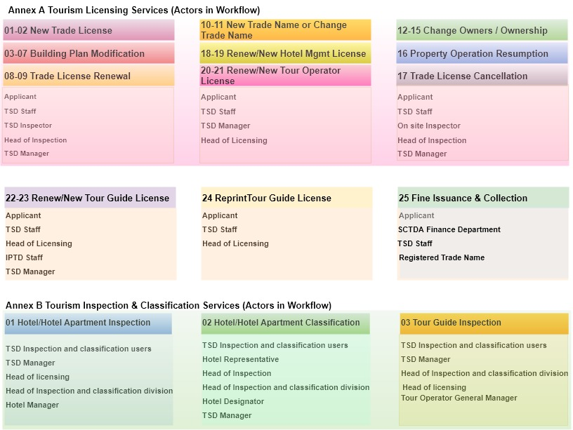

## Solution Objective

The main objective of SCTDA Licensing and Classification system is to automate the following activities:

* Tourism Licensing Services
* Tourism Inspection
* Property Classification

Verbat Intends to build the solution based on the RFP provided by the client. The following workflows (Annex A and B) and forms (Annex C) shall be considered as the primary development activity and might vary based on the detailed understanding of the system which will be carried on confirmation of the project.

**Annex A: Tourism licensing Services**

* New Issuance of Primary Approval to Obtain Trade License for a New Hotel/ Hotel Apartment
* Re-Issuance of Primary Approval to Obtain Trade License for a New Hotel/Hotel Apartment
* Issuance of Primary Approval for Modification in the building plans/drawings of new (for construction/under construction) hotel/hotel apartment
* Issuance of Primary Approval for Modification in the building plans/drawings of an existing and operating hotel/ hotel apartment to make changes in the interior/exterior structure (i.e. rooms, public area, restaurant, facilities, etc.)
* Issuance of Primary Approval for Modification in the building plans/drawings for hotel/hotel apartment building structure expansion (vertical/horizontal)
* Issuance of Primary Approval for Modification in the building plans/drawings to change trade activity, conversion from hotel to hotel apartment and vice versa
* Issuance of Primary Approval for Modification in the building plans/drawings to convert new existing building to a 4- or 5-star hotel/hotel apartment
* Issuance of Primary Approval for Trade License Renewal of Existing and operating Hotel/Hotel Apartment
* Issuance of Primary Approval for Trade License Renewal of Existing Hotel/Hotel Apartment that are in the process to operate or not yet in operation
* Issuance of Primary Approval to Obtain Official Trade Name for Hotel/Hotel Apartment
* Issuance of Primary Approval to Change Official Trade Name for Hotel/Hotel Apartment
* Issuance of Primary Approval to Change in Hotel/Hotel Apartment Owner
* Issuance of Primary Approval to Change in Hotel/Hotel Apartment Partners (Addition)
* Issuance of Primary Approval to Change in Hotel/Hotel Apartment Partners (Withdrawals)
* Issuance of Primary Approval to Change in type of ownership, i.e. company to individual and vice versa, etc.
* Issuance of Primary Approval for Hotel/Hotel Apartment Operation Resumption
* Issuance of Primary Approval for Trade License Cancellation of the Hotel/Hotel Apartment
* Issuance of Primary Approval to Obtain a New Hotel Management License
* Issuance of Primary Approval for the Renewal of Hotel Management License
* Issuance of Initial Approval to obtain a New Tour Operator Trade License
* Issuance of Initial Approval for the Renewal of Tour Operator Trade License
* Issuance of Initial Approval to Obtain a New Tour Guide License
* Issuance of Initial Approval for the Renewal of Tour Guide License
* Reprinting/Replacement of Issued Tour Guide License Card
* Fines Issuance and Collection/Payment

**Annex B Tourism Inspection and Classification Services**

* Hotel/Hotel Apartment Inspection
* Hotel/Hotel Apartment Classification
* Tour Guide Inspection

**Annex C: Sample Application Forms**

* SCTDA-TS-SRV-1
* SCTDA-TS-A001
* SCTDA-TS-A002
* SCTDA-TS-A003
* SCTDA-TS-A004
* SCTDA-TS-A005
* SCTDA-TS-A006
* SCTDA-TS-A007
* SCTDA-TS-A008
* SCTDA-TS-A009
* SCTDA-TS-B001
* SCTDA-TS-B002
* SCTDA-TS-B003
* SCTDA-TS-B004
* SCTDA-TS-B005
* SCTDA-TS-B006
* SCTDA-TS-B007
* SCTDA-TS-B008
* SCTDA-TS-B009
* SCTDA-TS-B010
* SCTDA-TS-B011
* SCTDA-TS-B012
* SCTDA-TS-B013
* SCTDA-TS-B014
* SCTDA-TS-C001
* SCTDA-TS-C002
* SCTDA-TS-C003
* SCTDA-TS-C004

The salient features of the application to be developed are noted below:

### Tourism licensing Services

#### Primary Approval for trade license for new hotel

##### *New issuance of primary approval to obtain trade license for a new Hotel/Hotel apartment*

##### *Re-issuance of primary approval to obtain trade license for a new Hotel/Hotel apartment*

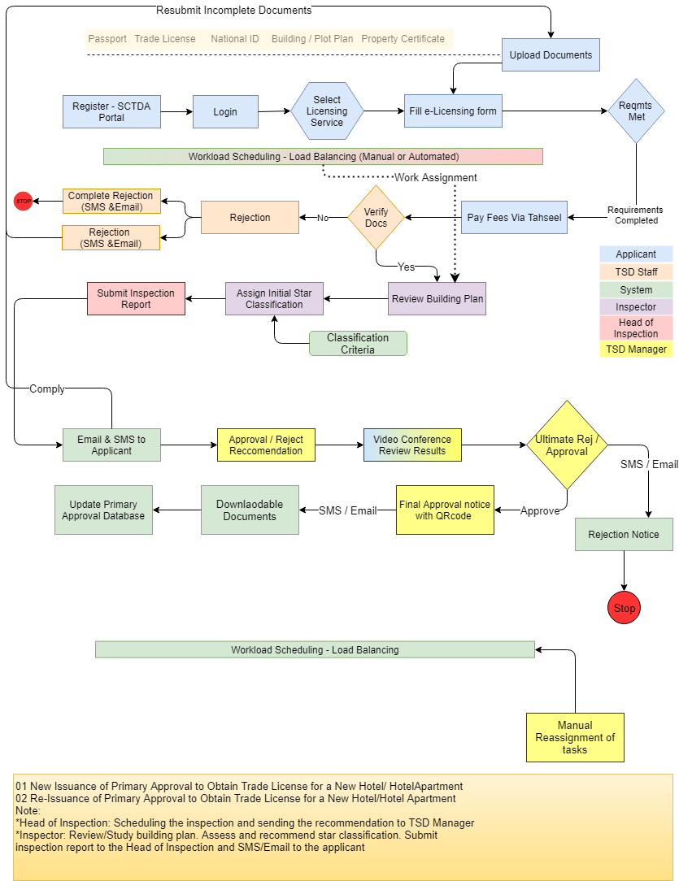

#### Approval for modification of building plan

##### *Issuance of primary approval for Modification in the building plans/drawings of new (for construction/under construction) hotel/hotel apartment*

##### *Issuance of primary approval for Modification in the building plans/drawings of an existing and operating hotel/hotel apartment to make changes in the interior/exterior structure (i.e. rooms, public area, restaurant facilities, etc.)*

##### *Issuance of primary approval for Modification in the building plans/drawings for hotel/hotel apartment building structure expansion (vertical/horizontal)*

##### *Issuance of Primary Approval for Modification in the building plans/drawings to change trade activity, conversion from hotel to hotel apartment and vice versa.*

##### *Issuance of Primary Approval for Modification in the building plans/drawings to convert new existing building to a 4- or 5-star hotel/hotel apartment*

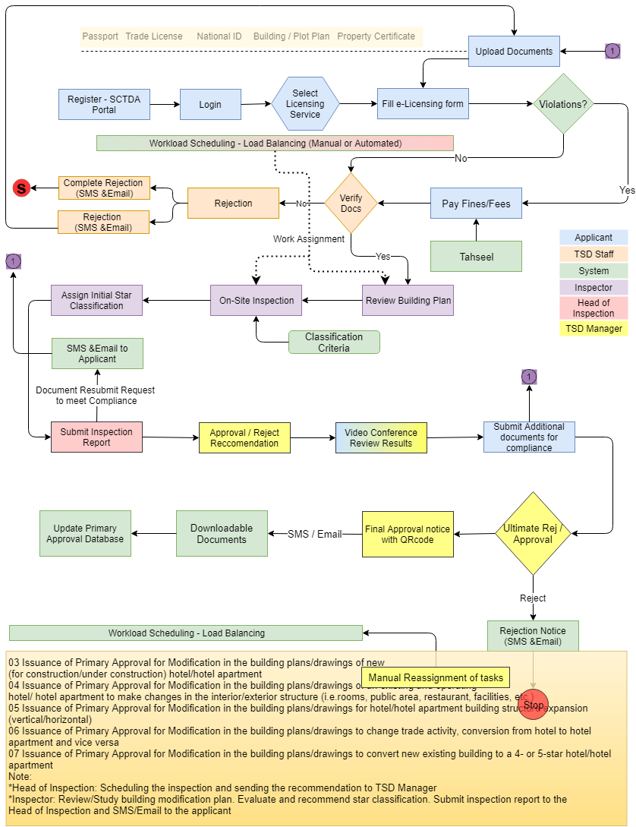

#### Primary Approval for Trade License Renewal

##### *Issuance of Primary Approval for Trade License Renewal of Existing and operating Hotel/Hotel Apartment*

##### *Issuance of Primary Approval for Trade License Renewal of Existing Hotel/Hotel Apartment that are in the process to operate or not yet in operation*

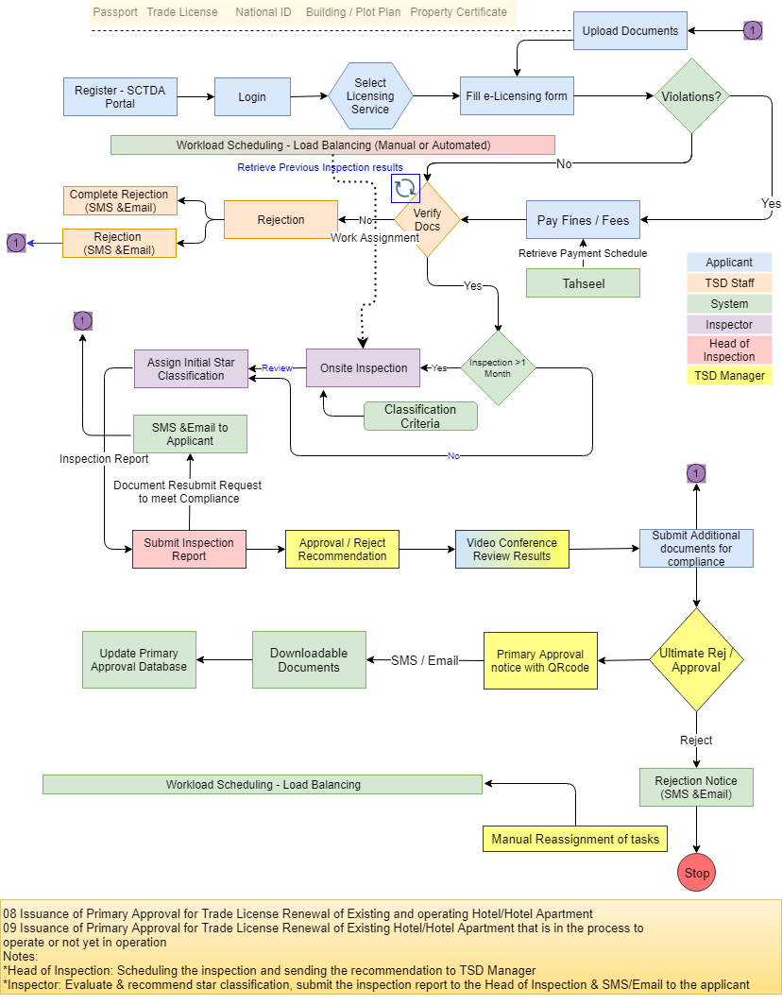

#### Approval for Trade Name

##### *Issuance of Primary Approval to Obtain Official Trade Name for Hotel/Hotel Apartment*

##### *Issuance of Primary Approval to Change Official Trade Name for Hotel/Hotel Apartment*

/Fees

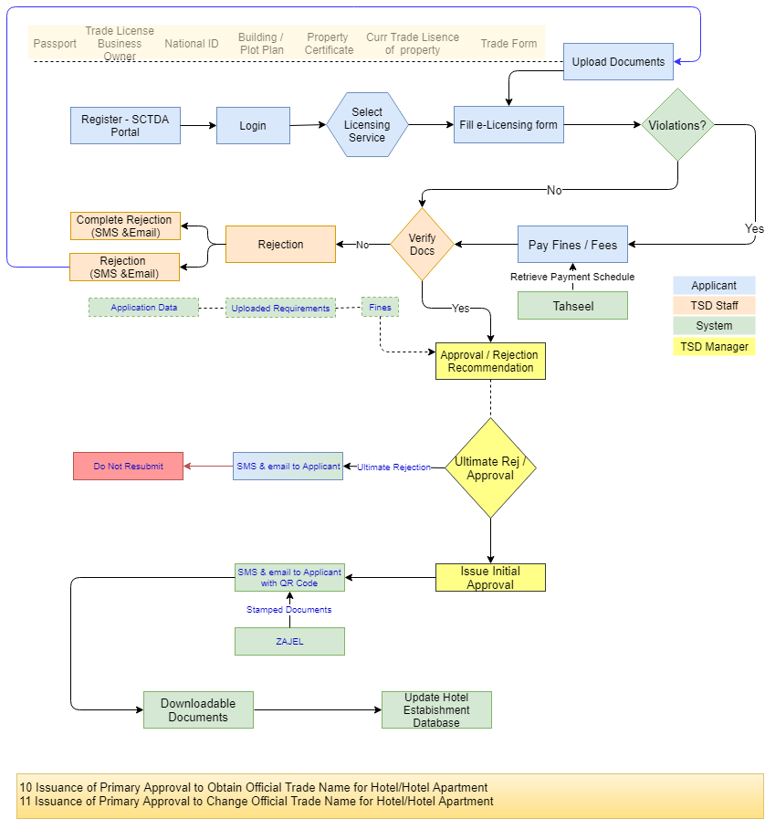

#### Approval for Hotel Ownership Change

##### *Issuance of Primary Approval to Change in Hotel/Hotel Apartment owner.*

##### *Issuance of Primary Approval to Change in Hotel/Hotel Apartment Partners (Addition).*

##### *Issuance of Primary Approval to Change in Hotel/Hotel Apartment Partners (Withdrawals)*

##### *Issuance of Primary Approval to change in type of ownership, i.e. company to individual and vice versa, etc.*

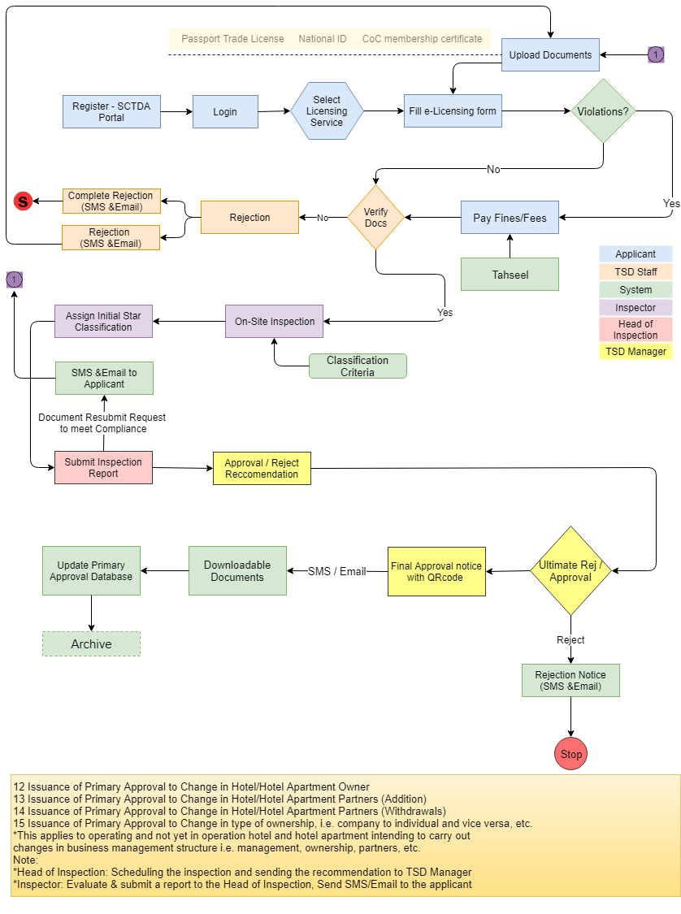

#### Issuance of Primary Approval for Hotel/Hotel Apartment Operation Resumption

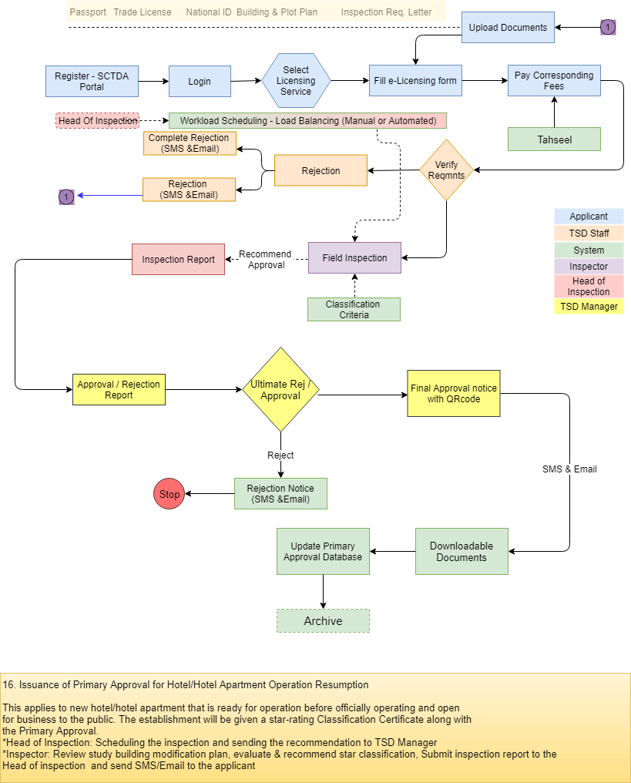



#### Issuance of Primary approval for Trade License Cancellation of the Hotel/Hotel Apartment

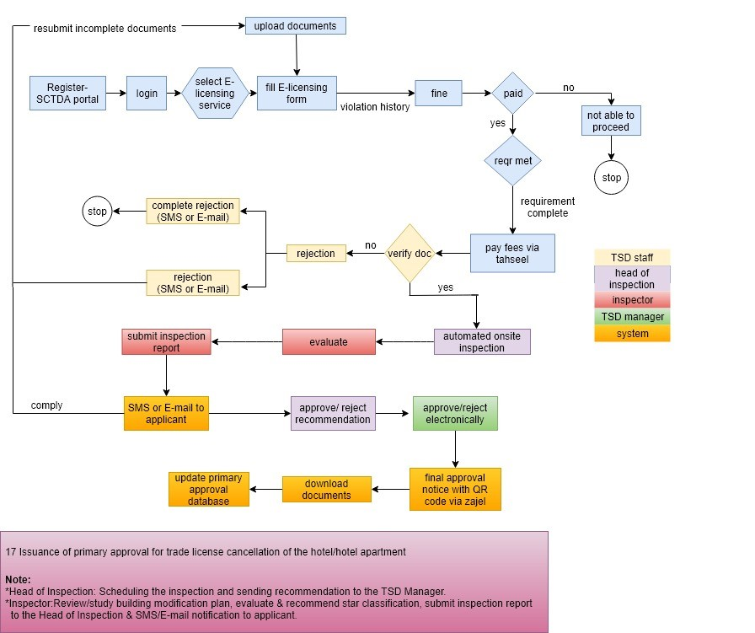

#### Approval for Hotel Management License

##### *Issuance of Primary Approval to Obtain a Hotel Management License*

##### *Issuance of Primary Approval for the renewal of Hotel Management License*

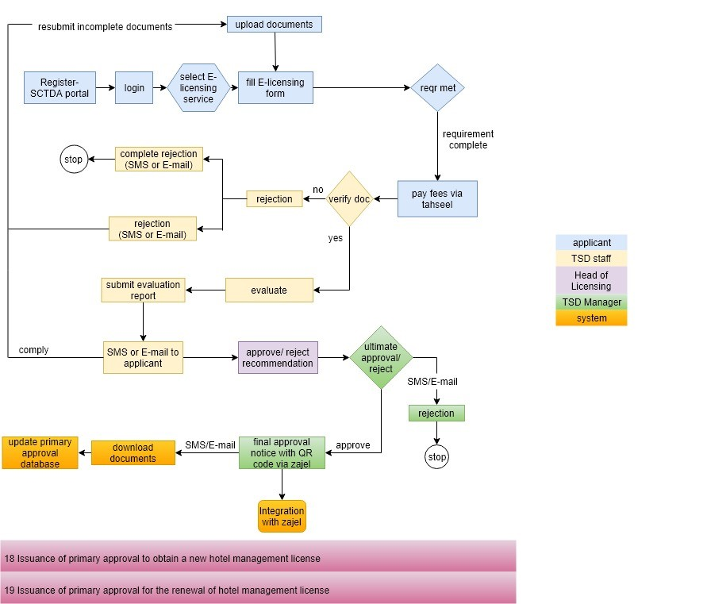

#### Approval for Tour Operator Trade License

##### *Issuance of Initial Approval to obtain a New tour Operator Trade License*

##### *Issuance of Initial Approval for the Renewal of Tour Operator Trade* License

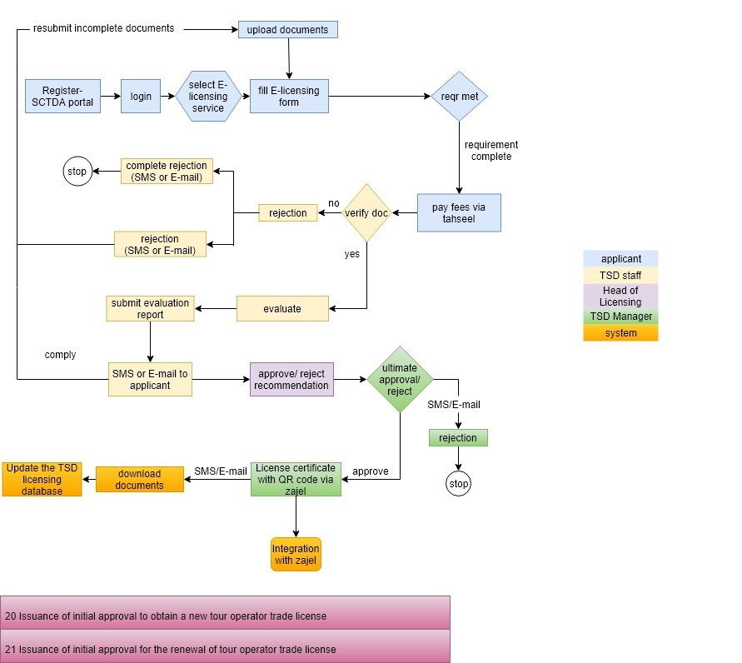



#### Approval for New Tour Guide License

##### *Issuance of a New Tour Guide License*

##### *Renewal of Tour Guide License*

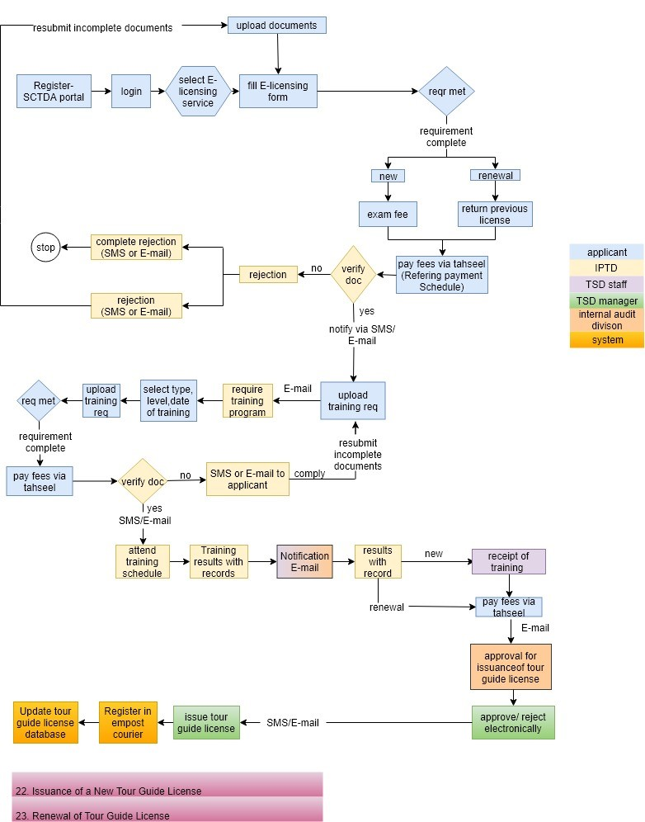

#### Reprinting/Replacement of Issued Tour guide License Card

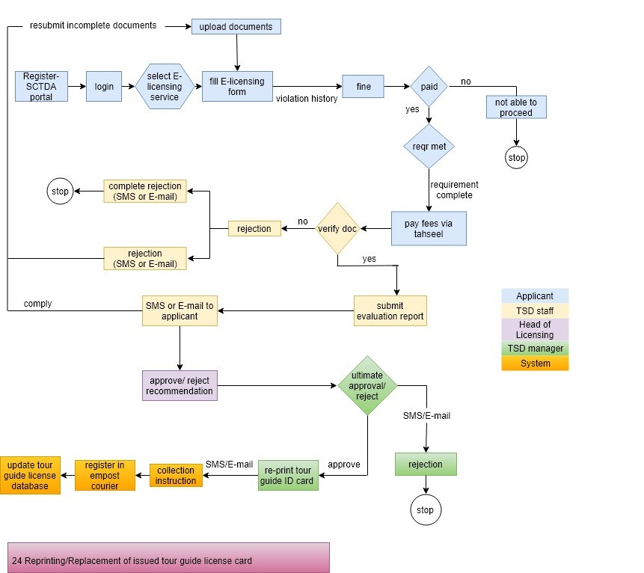

#### Fine Issuance and Collection/Payment

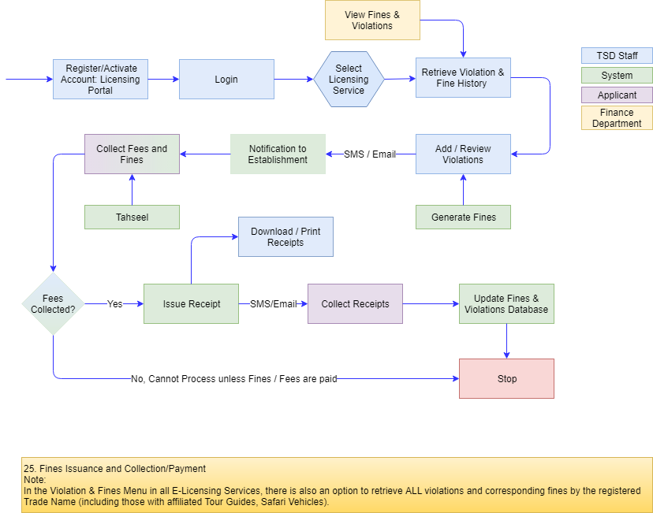

### Tourism Inspection and Classification Services

#### Hotel/Hotel Apartment Inspection

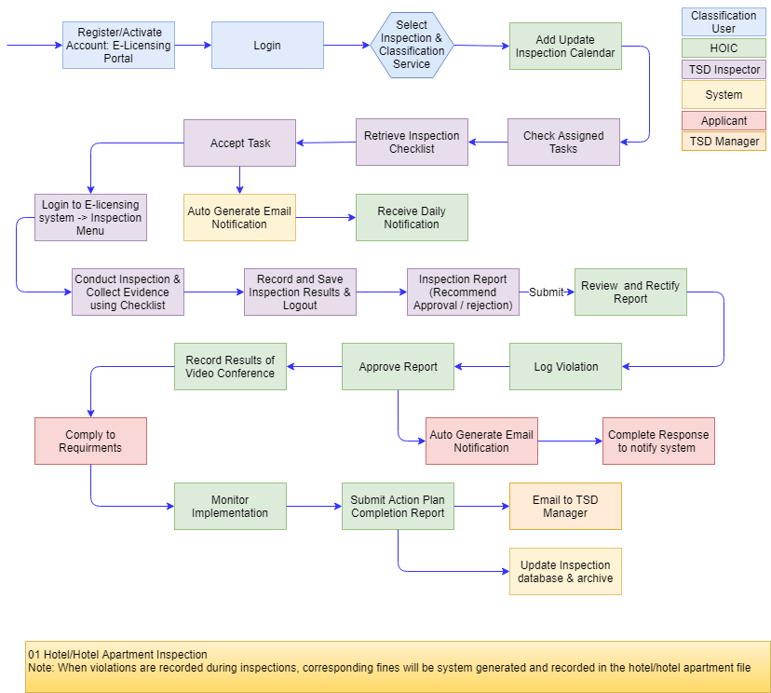

#### Hotel/Hotel Apartment Classification

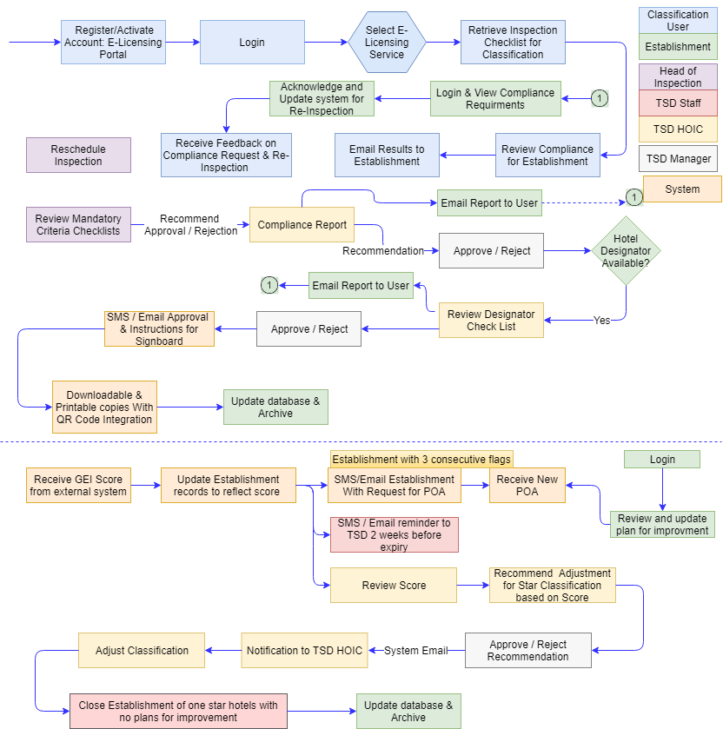

#### 1.3.26.3 Tour Guide Inspection

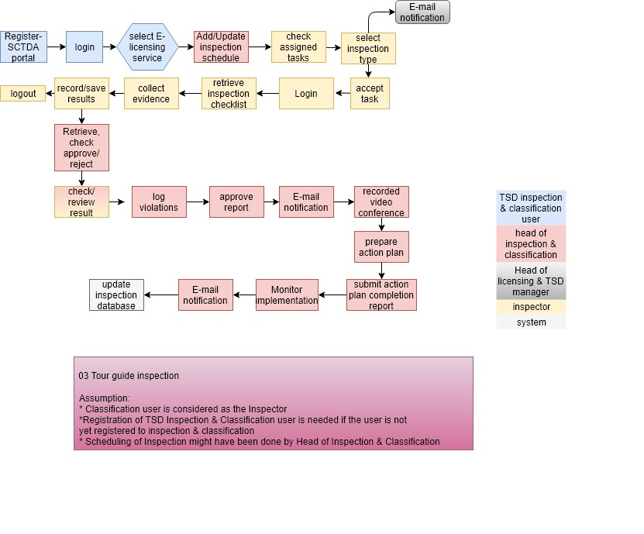

*Note:*

*The above workflows are created based on the details provided in the RFP and the initial clarification meetings followed. Verbat shall collect the detailed transactions, workflow, fields, and conditions etc. and document them in the Software Requirement specifications once the project is awarded.*

# Functional Specifications

## Web Application

|  |
| --- |
| **Annex A Workflows** |
| 01-02 (Re)New Approval for Trade License for Hotel |
| 03-07 Approval for Modification in the building plans |
| 08-09 Primary Approval for Trade License Renewal of hotel |
| 10-11 Primary Approval to Obtain/change Official Trade Name |
| 12-15 Approval to Change in Hotel/Apartment Owner |
| 16 Approval for Hotel/Apartment Operation Resumption |
| 17 Approval for Trade License Cancellation of the Hotel/Apartment |
| 18-19 Approval to Obtain a (Re)New Hotel Management License |
| 20-21 Approval to obtain a (Re)New Tour Operator Trade License |
| 22-23 (Re)New Tour Guide License |
| 24 Reprinting/Replacement of Issued Tour Guide License Card |
| 25 Fines Issuance and Collection/Payment |
| **Annex B Workflows** |
| 01 Hotel/Hotel Apartment Inspection |
| 02 Hotel/Hotel Apartment Classification |
| 03 Tour Guide Inspection |
| **Annex C Forms** |
| SCTDA-TS-SRV-1 |
| SCTDA-TS-A001 |
| SCTDA-TS-A002 |
| SCTDA-TS-A003 |
| SCTDA-TS-A004 |
| SCTDA-TS-A005 |
| SCTDA-TS-A006 |
| SCTDA-TS-A007 |
| SCTDA-TS-A008 |
| SCTDA-TS-A009 |
| SCTDA-TS-B001 |
| SCTDA-TS-B002 |
| SCTDA-TS-B003 |
| SCTDA-TS-B004 |
| SCTDA-TS-B005 |
| SCTDA-TS-B006 |
| SCTDA-TS-B007 |
| SCTDA-TS-B008 |
| SCTDA-TS-B009 |
| SCTDA-TS-B010 |
| SCTDA-TS-B011 |
| SCTDA-TS-B012 |
| SCTDA-TS-B013 |
| SCTDA-TS-B014 |
| SCTDA-TS-C001 |
| SCTDA-TS-C002 |
| SCTDA-TS-C003 |
| SCTDA-TS-C004 |
| **Admin** |
| **Master Data Management** |
| Licensing services List |
| Licensing service Fees |
| Licensing service fines |
| Licensing service periods (From - To) |
| Document Upload List |
| Document Requirements per service |
| User Types List (Role) |
| Reject reason codes & descriptions |
| Star Classification list |
| Inspection criteria list ( Create Checklist with weightage) |
| Criteria per Service |
| Forms List |
| Inspection Report types / List |
| Violations list |
| User management |
| Manage documents |
| Roles and Services (workflow) mappings |

|  |
| --- |
| **Main Modules** |
| **Applicant** |
| Login, Forgot password, Remember Password |
| Registration (basic profile) |
| Multi factor Authentication |
| Email verification |
| Select Service |
| Upload documents( Attach meta tags to the documents for search ability) |
| Application form |
| Display required documents list |
| Check Violations and Fines |
| Pay application Fees (Separate from fines) |
| Pay fines (Tahseel integration) |
| Download Documents |
| Receive Star ratings (UI Updates) |
| Receive Notifications |
| Dashboard Updates |
| Raise Disputes |
| **TSD Licensing Staff** |
| Verify document list |
| Manual verification of uploaded documents via visual inspection |
| Approve / Reject Application |
| Send SMS & Email |
| Request Additional Documents |
| Capture comments and results of the verification process |
| Create Inspection report based on results |
| Recommend Initial star ratings |
| **Head Of Inspection** |
| Review Inspector Report |
| Approve / Reject based on inspector Report |
| Schedule On Site inspection |
| Review Requirements |
| Approval / Rejection Recommendation for Primary Approval |
| Update Inspection Calendar |
| **TSD Manager** |
| Reassign Tasks |
| Approve / Reject Issue of Primary Approval |
| Approve / Reject Tour Guide License |
| Approve / Reject reprint of Tour Guide ID |
| Approve / Reject recommendation for adjusting star rating |

|  |
| --- |
| **Head Of Licensing** |
| Recommend to  TSD Manager for the issuance of Approval to Obtain/Change  Trade Name |
| Recommend to  TSD Manager for the issuance of Approval to Renew/new Hotel Management License |
| Recommend to TSD Manager for the issuance of Approval to Renew/new Tour Operator License |
| Recommend to  TSD Manager for the issuance of Approval to Reprint Tour Guide ID |
| **Tour Guide** |
| Tour Guide registration |
| Pay Tour Guide Training Fees |
| Register for Exam/Classes |
| **IPTD Staff** |
| Review Tour Guide Registration(Approve/Reject) |
| Verify Training(Pass/Fail) |
| Pass or Fail Exam |
| **Management (Finance, Internal Auditors)** |
| View Violations and Fines Menu |
| **Mobile App** |
| Mobile App API |
| **System features** |
| Authentication & authorization |
| Auditing & logging |
| Exception handling |
| Manage files and folders |
| Meta tags for documents and images |
| SMS & Email |
| Tahseel Integration |
| Payment Gateway Integration |
| Empost Integration |
| Hotel Statistics Integration( master data) |
| Vehicle Permit and Issuance System Integration ( master data) |
| Request pool for all actors |
| QR Code Generation |

## IOS Mobile App (iPad)

|  |
| --- |
| Basic Setup |
| Splash |
| Login |
| Forgot password |
| Dashboard |
| QR code library integration |
| Scanning |
| Create Classification Criteria |
| Create Inspection report |
| Onsite Inspection results |
| Collect evidence forms |
| Retrieve inspection list |
| Obtain Score for Hotel Designator |
| View Assignment |
| Take photo |
| Upload photo and documents |
| Submit inspection details |

*Note: The above given features and functionalities have been derived based on the details provided in the RFP and hence may vary after a detailed system study.*

# High Level Design

## Use case Diagrams

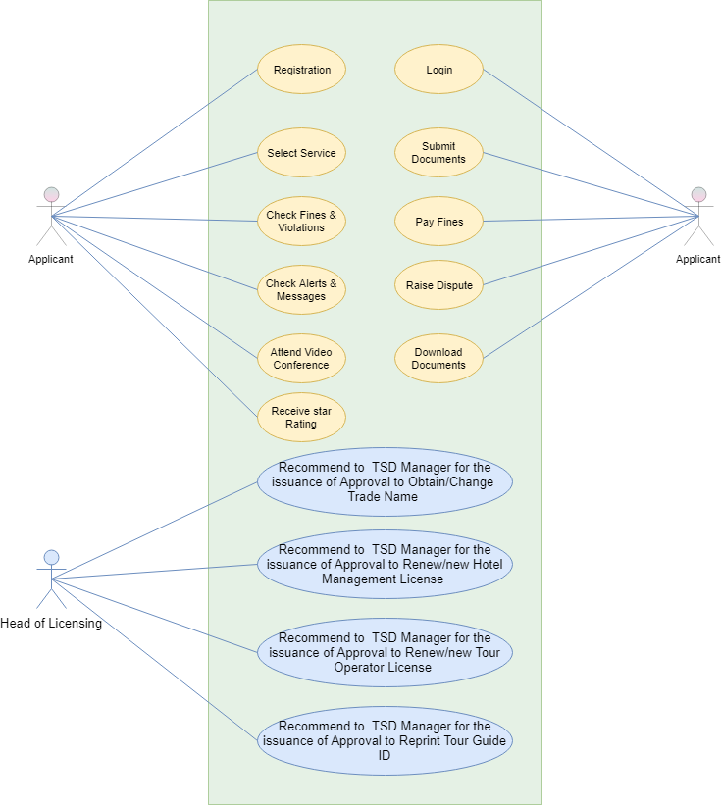

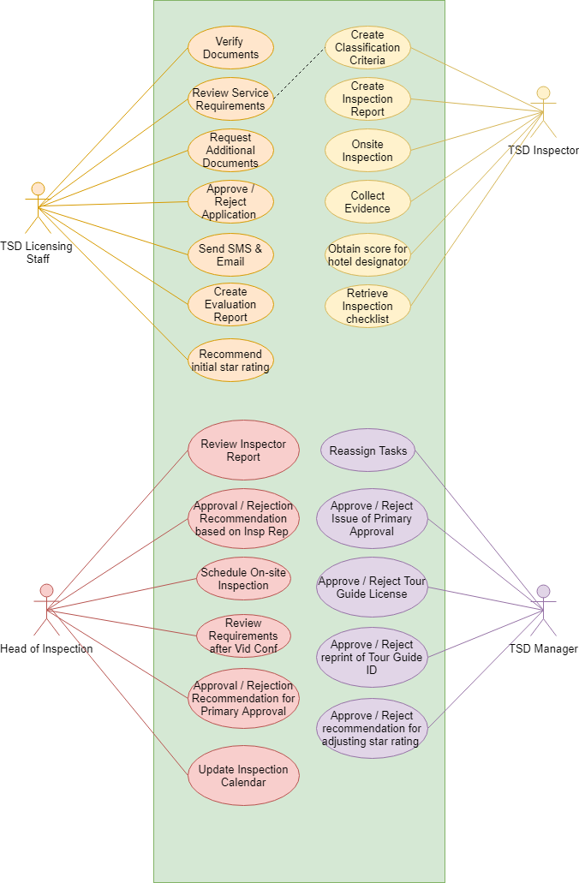

## Data Flow Diagram

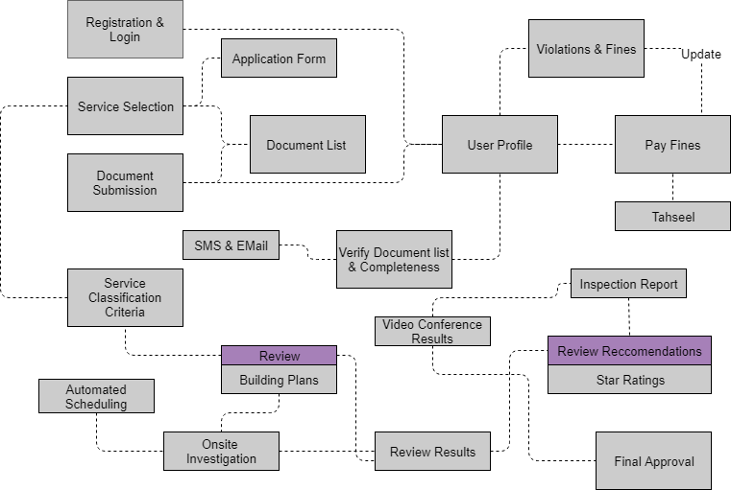

## Workflows

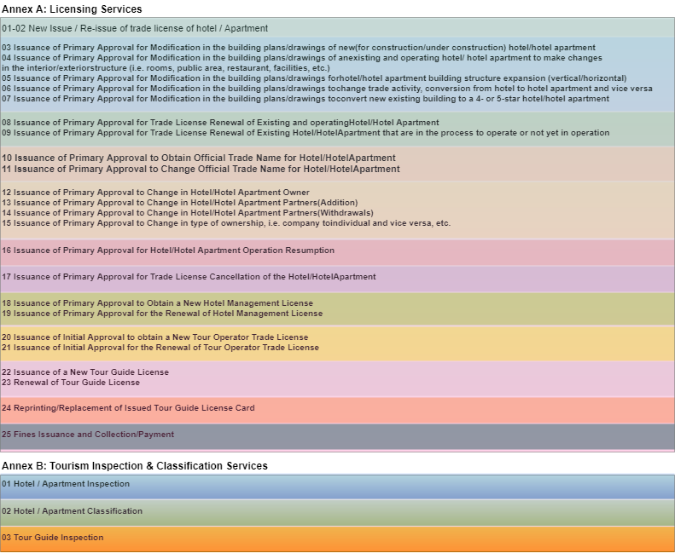

## Generic Workflow

## Functional Architecture

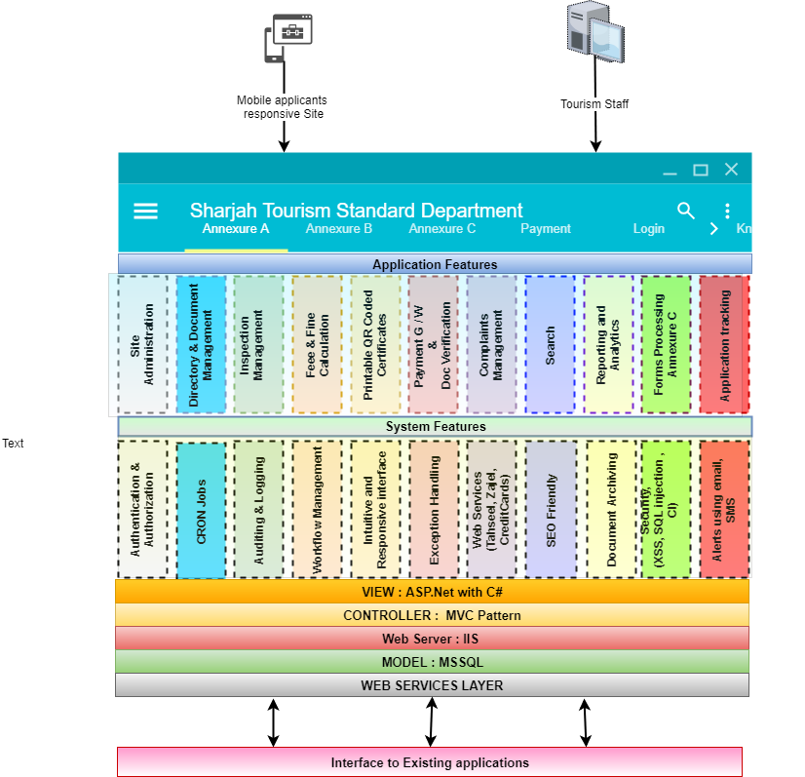

The proposed application is an MVC based application that is technology agnostic. In the section titled “High Level Architecture”, Verbat has proposed a reference implementation using .Net Application Technologies (more details covered in that section), but this is by no means is a limitation on the proposed technical architecture. The functional architecture depicted above broadly classifies the features of the proposed implementation into “Application” and “System” level features.

System level features are what Verbat considers as non functional requirements while the application level features are functional requirements that were stipulated by the client. Below you will find a run down of the various features that the proposed application will have.

## Application Level features

* Site Administration: An enterprise site administrator will manage various aspects of the site. Site administration consists of activities such as (but not limited to)
  + Adding new users, assigning roles
  + Adding new items to the inspection checklist
  + Uploading documents
  + Mining logs to identify system issues
* Directory and Document Management: The application tracks and manages the documents uploaded by the users. Documents are filed into directories (conceptually) that are uniquely identifiable and assigned to the user. Directories may also contain other attachments such as the results of the inspection logs
* Inspection management: Inspectors shall be assigned to jobs based on availability, schedules etc. The application automates the inspection assignments based on some predefined parameters. These assignments may be overridden and reassignments can be made if needed.
* Fee and Fine Management: Applicants shall be able to get the fees and fines that are posted when they make their applications. It is assumed that the fees and fines are already in the system (or in a third party application)
* Downloadable/Printable Approvals: Approvals and certificates with QR codes will be generated by the system. These approvals and certificates shall be available as downloads to the applicant.
* Payment gateway and Document Verification: The system allows users to make payments of fees or fines using integrated payment gateways or using Tahseel.
* Complaints management: The applicant shall be provided with a means to dispute the results of the inspection report or dispute causes for rejection of their application
* Search: An integrated search can be used within various modules to look up applicants & Applications by category, status, date etc.
* Dashboard with Reporting: Custom dashboards shall be provided to the various stakeholders of the system. Depending up on their entitlements various reports and analytics will be available.
* The dashboard shall have request pools that contain the list of applications that need to be processed. The pool will contain applications in various stages and having various statuses
* Forms processing: The system has various forms. These forms have various pieces of functionality/information that are common. Common data management and retrieval techniques will enable the application to be more scalable and adaptable
* Application tracking: Any time during the application process, users will be able to track the progress of their application.

## System Level Features

* Authentication and Authorization: The system will validate the identity of the user and then authorize the user and assign a specific role that they have been mapped to by the admin
* Auditing and Logging: The system will log the activity of the logged in user so that it can be tracked for security purposes. The system will also log the actions being performed by the system so that it can identify issues caused by systemic application failures
* Scheduled Jobs: The system will have scheduled jobs running at specific intervals. The scheduled jobs makes it possible to dynamically assign inspection schedules as well as send reminder emails, notifications etc.
* Workflow Management: The application maintains different queue for different roles. When an applicant has fulfilled his application requirements, the system will move the application to the concerned staff. Workflow will keep track of the different states that the application has gone through so that it can easily be queried by the concerned user
* On Screen Guides: On screen guides provide context sensitive guidance based on the role of the logged in user. Textual hints will also be interspersed across different elements on the site
* Exception Handling: As a part of managing user expectations, exceptions or inadvertent application failures will be handled by providing user friendly and contextual error messages. All exceptions will be logged for future reference so that it can be handled better.
* Web Service integrations: Web service framework to integrate various third party integrations such as credit cards, Tahseel etc. will allow for the application to freely exchange information.
* Localization & SEO Friendliness: Localization will allow for the application to be multilingual, so that it can display different currencies, languages and direction of the flow of text.
* Document Archival: An application that must handle a large amount of documents for its various users, must find a way to archive documents that are no longer used or documents that belong to expired accounts. Archival provides a means by which these documents can be securely stored on a resource dedicated for it. Verbat will provide the mechanism for archival, but the client will have to provide hardware or software necessary to fulfil this requirement
* Security: Security of the site is managed through a combination of the logs maintained by the system as well as additional functions such as
  + Secure communication using SSL
  + Password salting
  + Provision to secure the site against Cross Site Scripting attacks (and reflected XSS), SQL Injection attacks, Code Injection , buffer overflow vulnerability
* Messaging: A messaging framework to support communication via email and SMS messages for the various function points in the system.
* Meta Tags: The system shall automatically Tag documents and images being uploaded by the user. These tags shall be assigned based on context. Additionally user shall have the ability to assign custom tags

## High Level Architecture

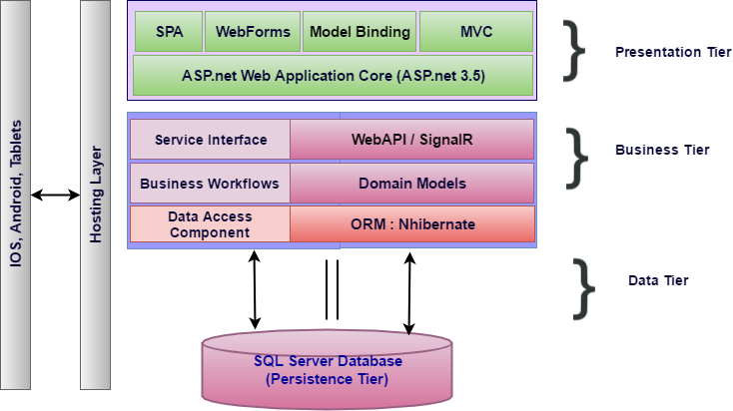

Figure High Level Technical Architecture

The proposed architecture combines the classic MVC architecture along with elements drawn from Service Oriented Architecture (SOA). SOA compliments the requirement where the client’s needs to extend the functionality of the application by retrofitting add-on services in the future.

The business layer represented in the figure above is a service layer that is modelled by the business domain. Hence it becomes easy to contain and isolate workflows. Each service layer results from the culmination of a broad range of granular micro services that work in concert to deliver the desired functionality. If there is a future need for adding new services, this can easily be accommodated by building a parallel pipeline.

Traditionally front end design of .net based applications are done using ASP.net web forms or web pages, but now a days most web applications take advantage of Single Page Applications (SPA) like Angular, a framework that loads a single HTML page and dynamically updates the page as the user interacts with the app. SPAs use AJAX and HTML5 to create fluid and responsive Web apps, without constant page reloads. This is particularly useful, since one of the requirements for the application is a state-full page that supports persistence.

MSSQL is preferred relational database, as per the client. For Rapid Application Development (RAD), most application frameworks employ Object Relational Mappers (ORM). .Net supports both nHibernate as well as Entity framework, both of which are ORM’s. ORM’s support rapid application development by side stepping the work related to managing the intricacies of a relational database. ORM’s also make the application agnostic to database technologies (Such as Oracle, MySql, MSsql etc.).

In order to support portable devices that needs to communicate with the application, Web API’s are implemented and are exposed using restful web services. To enhance and enrich the mobile experience Web services are clubbed with SignalR, a library that simplifies the process of adding real-time web functionality to applications. Real-time web functionality is the ability to have server code push content to connected clients instantly as it becomes available, rather than having the server wait for a client to request new data. This would be of great importance as it will push the latest updates to the handheld devices operated by Inspectors. By doing so the devices could be used both on-line and off-line (Where cell phone reception is bad)

# Nonfunctional Requirement (Others)

|  |  |
| --- | --- |
| **Requirement** | **Details** |
| User Experience and  UI Design | * The application will be developed only in English * The layout and graphical components will be created considering the usability factors |
| Performance | * Application will allow users to have smooth and quick access to the information or services they require. |
| Security | * Web security standards will be followed. |

# Assumptions

The project solution and technology is created from the initial understanding of the requirement shared with Verbat through mails and meetings. The proposed solution is based on the following assumptions:

1. **Objective:** 
   * The requirement is to develop an Web and Mobile Application (Android & iOS) with the functionalities as defined in the “Functional Specifications” section
2. **Design:**

* The Client shall provide the branding guidelines
* Color theme shall be provided by the Client
* Client shall provide licensed images and logos in specified size & format
* Text should be provided in digital format preferably in MS Word 2013 or above
* Client will purchase the necessary templates needed for development
* Verbat may use template based design for the application
* This application designed for mobiles(iPad) will be in portrait mode

1. **Development:**

* Development Contingent upon timely feedback from client
* Requirements should be well defined, agreed and signed-off by the Client
* The client will finalize the functional requirements & prototype before the commencement of the development of the project
* The proposed application front end and backend would be developed in English
* User manuals shall be provided only in English
* The mobile app for Inspectors will be developed on IOS platform
* Client shall provide the developer accounts for IOS Store.
* Mobile Application elements or design cannot be modified once the app is deployed
* This estimate is only for portrait orientation on iOS iPads (Not iOS mobile phones)
* Supporting OS:
  + iPad(iOS 10 and above
* Client to provide all necessary API’s and details for third party integration
* Client will provide relevant information regarding Integration with external systems like Tahseel, Empost, etc. (to Verbat’s satisfaction) to estimate the actual efforts and it may vary depending on types / modes of integration, areas of integration etc.
* Client will procure templates, SSL certificates (if applicable) & Payment processor
* SMS and Email gateways shall be provided by the client
* Reporting and analytics may require external tools. Current assumption is that analytics will be minimal and simple.
* Report format will be predefined and shall not be user defined.
* The report format to be provided by client.
* The solution will provide maximum of 15 predefined Reports that will serve the several department objectives. Additional reports can be added based on client request.
* Pre-defined format for print and format will designed in HTML and print in plain paper
* Automated task re/assignment is only applicable to tasks related to Inspector.
* Client to provide detailed workflows of each licensing process before start of the project
* UI development effort is 6 hrs. per additional screens with medium complexity.
* The effort estimate is based on the assumption of the workflows.
* The workflow diagrams represented in this document is an approximation of the workflow descriptions provided by the client. The actual requirements shall vary based on the requirements collected.
* For the sake of simplicity complex workflows have been simplified and may not contain all the actors or processes
* The RFP clearly states that it does not cover all of the details needed for the service provider to make an accurate estimation. The estimate provided is with reference to the information provided by the client. If Verbat finds during the requirement gathering phase that the actual requirements uncovered are different form the original and thus might affect the estimates provided, it shall exercise rights to renege on the contract
* Forms in annexure C are considered to be part of the workflow related to Annexure A & B. Client is responsible for translating the forms to English
* Mobile App shall collect information in appropriate forms when it is offline. Once the device has access to a wireless provider, the application will manually sync to the source
* The report definition shall be defined at design time. The application shall not have the ability to change the Report definition dynamically at run time. User friendliness relates to the ease in presentation, sorting and filtering of report data
* It is unclear how fees and fines are levied or the process by which they are entered into the system. The effort estimate is based on a rough guesstimate that assumes a workflow with relatively modest complexity
* Proposal Does not contain an effort estimate for training
* Integration related to master data with the existing vehicle permit system shall be provided by Verbat. Effort estimation for Integration with an existing hotel permit system that has not been ascertained.
* Gateway to be provided by SCTDA.
* Client will provide the required licenses, API, documentation and support for integrating with third party BI tools
* Client shall provide the storage required to host images and documents
* Documents and images shall be made searchable based on the Meta tags provided during the time of upload. System will automatically assign tags where relevant at the time of upload
* OCR Technology will not be used to aid document search or for extracting the textual content of documents
* Video Conferencing is outside the scope of the workflow. Client is responsible for storing and archiving videos.
* The application shall not provide any interfaces to play or review videos
* Inspection and classification user is same and they are reporting to Head of Classification and Inspection division
* TSD staff = TSD licensing staff= Licensing Division staff = TSD Licensing User Note: TSD staff is reporting to Head of Licensing Division
* Migration --- ---- --- ---
* Final data needs to be entered by the client via the application
* Client will provide sample data to test the entire application
* Testing of web application will be done in latest versions of Google Chrome, Mozilla web browsers only
* Testing of the mobile app will be executed on devices mentioned under Technical Standards
* Client will host and manage the application on infrastructure (server / cloud) recommended by Verbat for managing database and application backup inclusive of images
* Application and data backups are subject to the purchase of such services at an extra cost
* Internet connectivity is required for the functioning of the web application.

# Out of Scope

With the ever evolving digital market, the requirement needs should be clear to both the parties involved, hence the importance of mentioning the out of scope details of the project. Following are considered to be out of scope while creating this proposal.

* Purchase of images, fonts
* Any language other than English
* Database migration
* Content writing / proof reading / Data Replication / Manual data entry
* Content or image procurement or uploading or editing
* Audit Trail
* Adding new features to the application other than mentioned in the functional specifications. Such requests will be handled via change management. For Change management details, please refer section titled “Change Management” in the Proposal.
* Annual Maintenance Contract (Bug fixing, debugging, enhancements) – Please refer section titled “Maintenance and Support”.
* Hosting Infrastructure and Maintenance
* Application Deployment on the server/ Physical deployment onsite / installation of the application in devices and Physical connection, installation of system
* Deployment of the mobile app on the Apple Store.
* Integration with third-party, if any, other than mentioned in the functional specifications
* Hardware Integrations / procurement and purchase
* SSL Purchase and installation, if any
* Plugin purchases, if any
* Backup solution and Disaster recovery
* OS other than mentioned in the Hardware Interface
* Relevant / related software libraries
* Migration of the data from the current solution to the new solution
* Reputation Management system
* The video conference
* Zajel Integration
* GEI Score Report is out of scope
* Video Conferencing, Video File storage, retrieval or views

# Technology Solution

## Proposed System Environment



IIS.Net 4.5  
MSSQL

MVC / C# / XCODE

HTML / CSS3

**MS SQL2012  
Windows 8/10  
Web Services**

## Technical Configurations

### Development Tools

* Visual Studio, MVC, C#, XCODE, Objective C
* MSSQL
* HTML / CSS 3
* Ajax, JavaScript, JQuery

### Recommended Web Hosting Package

* Medium CPU power – single to dual CPU
* Single Domain
* Windows Sever 2012R2 Data Center
* Disk Space: 5 GB
* Monthly Bandwidth: 10 GB
* Web site Server Software – IIS 8.0

### Browser Compatibility

* Chrome version: 56
* Firefox version: 51
* Edge version: 39

### Hardware Interface

The application is reliant on hardware interfaces to provide a seamless automated user experience.

* Computer with Windows 8 or 10 OS
* Compatible Browsers as specified in section 8.2.3
* iPad(iOS 10 and above)

### Technical Standards

|  |  |
| --- | --- |
| Particulars | Specifications |
| Screen resolutions | 2048 x 1536 |
| Testing Devices | * iPad Mini 2 |
| OS Version | * iPad( iOS 10 and above) |

### Technical Guidelines

The guidelines provide instructions and conditions that will be adhered to during the development of the mobile (iPad) application

* API (provided by the client) will be used, as the case may be in realizing the features and functionalities mentioned
* The Client will finalize the functional requirements and wireframes before the commencement of the project
* Verbat will be testing the app in the mentioned devices only, testing on devices other than the ones mentioned under the “Technical Standards “will have to be specified and provided by the Client at the beginning of the development phase.
* The Client will have to provide the details of the testing devices they are using before the start of development phase
* Client should provide the relevant Developer's Account credentials before the development phase. In case Verbat needs to create the developer id, additional charges will be incurred by the Client
* The duration mentioned in the project time line is for development and testing and any delay or time taken by the review team to respond will not be Verbat’s responsibility
* Any clarification required from client needs to be addressed within 24 hrs.
* The apps will be developed / created within the guidelines of Apple

Verbat will strictly follow the guidelines provided by the respective stores. Verbat will inform the Client if the any of the Client requirements/ request deviates from it.

* Customization of the features of the app will be susceptible to the limitation imposed by the respective platform/store.
* Once development commences, the test device/screen sizes will not be susceptible to change. Any change requested by the Client will have to go through change management
* OS version support will be limited to the ones mentioned in the technical specifications. Further support will have to go through change management

# Delivery Management

## Project Management

The Verbat development center strictly follows industry standards on quality. The project management is process governed by the Verbat Quality Management system and is put to verification through internal audit programs that happen from time to time.

Verbat will dedicate a project manager for the proposed implementation. Verbat proposes Client to identify one project manager who will be driving activities to be undertaken by Client to be the single point of contact for Verbat.

## Roles and Responsibilities

Verbat will assign a dedicated Project Manager/Project Lead to lead the project, who will be the first point contact for Client. He/she will be responsible for planning and managing the various activities within the project. He/she will work closely with Client Project Manager, to give periodic status updates and ensure high level of visibility and comfort on the progress of the project.

The Project Manager/Project Lead will lead the co-ordination between Verbat and Client, thus enabling smooth transitioning of Client requirements to the Verbat’s offshore delivery team, and provide visibility as well as comfort on the progress of the services to Client.

He/she will have periodic meetings with Verbat’s Senior Management, thus ensuring Verbat’s Management commitment and focus on Client initiatives.

## Delivery Activity Summary

|  |  |
| --- | --- |
| Activities | Description |
| Detailed requirement Analysis | Verbat team to conduct detailed study of requirement for the phase. If clarification is required, team will reach out to Client for more information and/or time for discussions. |
| DB Design | DB design for central and test DB. |
| Software Requirement Specification document (SRS) | Once the requirement analysis is completed, Verbat team will submit the SRS document for approval |
| UI/UX Design, Prototyping | Based on the SRS, Verbat UX/UI team will work on the UI/UX of the screens and submit a prototype for approval |
| Functional Specification Document (FS) | Once the Prototype. UI/UX is approved, Verbat shall submit an FS document for approval. |
| Development | Actual system development starts based on the FS. This involves detailed design and software development of Web/Mobile Application. |
| Testing | Test Planning, test plan creations, internal, integration testing and user acceptance testing. |
| Deployment | Deploying the latest built in the Verbat Test Server. |

## Project Implementation Plan

Verbat will be providing the solution in a stand-alone fixed bid approach or managed solution model which ensures minimum viable solution for quick wins with core focus on the long-term business objective and outcome. Once the implementation is over, Verbat will initiate the application maintenance process (once the maintenance contract is signed) which continues to extend after the implementation.

## Deliverables

* Project Plan
* Software Requirement Specification Document (SRS)
* Prototype of the application
* Functional Specification Document (FS)
* Fully Developed & Tested Application
* User Manual
* Source Code

## Estimated Delivery Time

* **UAE working days for the prototype from the date of approval of the SRS.**
* **UAE working days for the development of the application from the Date of Approval of the FS.**

| **Activity** |
| --- |
| Contract Signoff (T0) |
| Project Initiation & Initiating requirement gathering |
| Software Requirement Specification Document(SRS) |
| SRS Approval (T1) |
| System Prototype-Complete |
| System Prototype-Approval (T2) |
| Functional Specification (FS) |
| FS Approval (T3) |
| Development Phase-Complete |
| Perform QC (Unit Testing and Integration Testing) |
| System ready for UAT |
| UAT Acceptance on Verbat server (T4) |

*Note:*

* *The above-mentioned timeline is in UAE Working Days*
* *The initiation of the prototype is dependent on the confirmation of SRS. SRS will be submitted post the confirmation of the project, receipt of LPO, signed proposal and advance payment*
* *Documentation submitted after project initiation and system study supersedes any proposal or documentation submitted during initial requirement gathering / discussion / negotiation*
* *The above mentioned timeline for development is post the confirmation of FS*
* *Project plan will be submitted post the confirmation of project with necessary payments*
* *Any delay in getting the approvals of deliverables from Client will cause change in timelines and the revised timelines will be updated in weekly status reports shared with Client after the project commencement*
* *All approvals and queries regarding the client requirement and any queries which may hinder the project advancement at any stage should be answered by the client within 24 hours from the time of initiation, failing which the time delay will get added to the actual effort and timeline which was estimated.*
* *An average of 20 working days are assumed in a month*
* *On project confirmation, Verbat requires a lead time of 14 days for resource mobilization.*

## Deployment Details (at Clients Behest)

* Client can opt for hosting the application at Verbat’s Server.
* If deployment is at the Client’s server, responsibility of deploying the application onto the production environment after conducting the necessary acceptance testing will lie with the Client unless and until Verbat’s support is contracted for deployment.

*Note: Hosting the application at Verbat’s server will call in for additional charges.*

## Release Planning

* Client will be informed about the release date and time through email.
* Client performs the UAT

## Risk and Contingency Planning

Verbat has identified various risk factors associated with this assignment and understands the impact of these risk factors on the project schedules. The objective of this section is to highlight for both Verbat and client, the risk factors, to analyze the impact of the risks on project execution, and to propose strategies to control and reduce the impact of the risk factor.

These various risks, which could arise during the project, are tabulated below along with mitigation implementation.

| Type of risk | Impact | Risk Mitigation | Risk Handling |
| --- | --- | --- | --- |
| Scope Creep | H | Functions and features will be detailed in system requirement documents and will go through client approval. Once this document is approved, any change to requirement will go through change management review for possible impact assessment. | Proper change management procedure will be implemented. |
| Delay in customer feedback | H | The plan is prepared with enough lead-time for customer reviews and approvals.  The customer is indicated with the dates when the document is expected after review and approval. | The request for feedback will be escalated if not attended at the right time so that the schedules are not affected. Deemed acceptance criterion is set up front and will be followed. |
| Non-availability of necessary software’s, frameworks, database instances and infrastructure at client’s hosting environment(If hosting support is provided by Verbat) | M | Client will be informed in advance on these requirements. | Possible impact to schedule. |
| Manpower attrition | L | All efforts would be made to ensure process dependence rather than being person dependent. As a risk mitigation plan Verbat will train backups. | A new person will be identified as early as possible, provided the required project-specific training and mentored by the senior members of the team to minimise impact of attrition on the project. |

*H-High, M-Medium, L-Low, NA-Not Applicable*

# Change Management

Any addition which comes out of the project scope, upon and after the launch of the tool will be considered as change management. Verbat recommends the following change management procedure for the same.

* Any change which comes out of the project scope, which was discussed, documented, and mutually approved by both the parties in the requirement stage, will be carried out only through raising a change request.
* Change request will be studied and an impact analysis on the existing work flow will be performed.
* On finalizing the impact, effort estimation for the change will be calculated and raised as additional requirement.
* Verbat will initiate the change request only after getting a formal approval from the client for the additional changes raised.
* Any change from the scope will be charged at the agreed man day rate (refer financial proposal) and approval from the clients will be availed before commencing on any change management.

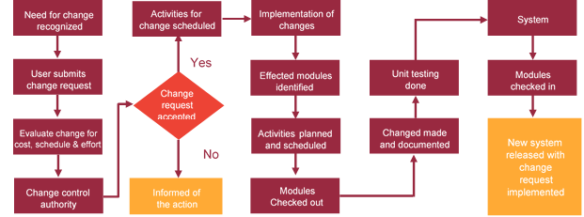

# Miscellaneous

## Acceptance Criteria

* UAT sign off should happen within 14 Days from the release of each module/ Phase and the acceptance confirmation needs to be mailed to Verbat failing which Verbat will consider the project as approved by the Client.
* Any comments or reason for rejection need to be documented and the same needs to be sent as an email from the official mail id of Client to Verbat on or before 14 days from the first release.
* Timeframe for acceptance for any further release will be mutually agreed and finalized between Client and Verbat depending on the UAT Comments.

## Warranty

* Verbat shall provide a bug ﬁx warranty at no additional cost for 30 days from the date of acceptance of the project, for correction of any errors in the developed application that may be attributed to Verbat.
* However, this does not cover modifications by Client, or use of the application on an environment other than the proposed environment, or other circumstances outside Verbat’s reasonable control. In such a case Verbat reserves the right to charge for its services.
* All error corrections will be executed at Verbat India office. In the event of any need for on-site work, all expenses incurred for such trips will be payable to Verbat by Client.

## General Terms and Conditions

* Offer Valid for 30 calendar days from the date of submission of the Proposal
* All the projects activities will be carried out from our off-shore development center in India
* All the documentation will be provided in English.
* Third party components may be used to develop this application.
* The scope of the project is to develop the Application as detailed in the scope of the project and mentioned in this proposal. Any changes or additions will have to go through change management.
* This proposal would have been derived or concluded from either the RFQ /RFP/data shared via email / information transferred during an initial requirement analysis meeting / tele-conversation. Verbat Technologies reserves the right to change the terms of this proposal as the final terms (including the costing), features & functionalities and timeline could change during the course of the project. Hence any fees quoted / timeline committed in this proposal may not be considered as final unless agreed and signed by both parties.
* Web Application will be best viewed only in the environment mentioned in the section Browser Compatibility
* Mobile app will be best viewed only in the environment mentioned in the section Hardware Interface
* All Source Code and other project artefacts would adhere to the Verbat document templates and internal coding standards
* Acceptance criteria shall be based on the clauses which were mutually discussed between Verbat and Client at the Requirement Analysis phase and the same will be documented and approved by both parties through official emails
* In case Client requires any extension of the proposed acceptance schedule, the associated effort and cost of such extension can be mutually reviewed
* For any circumstances if project needs to be put on Hold / Stop it requires minimum request notice period of 14 days along with duration for which request will be addressed by management and final decision on the request will be based on that
* If deployment is done in Client’s server, Verbat cannot be held responsible for any performance issues arising due to hardware malfunctions.
* Client is responsible for data backup in case the application is not hosted on Verbat server
* Source code will only be delivered or uploaded on the Production Server once the due payments are made.

## Assumptions and Dependencies

* Detailed system study is required before the start of the project.
* During the requirement gathering phase, authorized personnel from the Client’s side is expected to be available for discussion and finalizing the HLD (High Level Design), before development commences.
* Type of reports and formats, if under the scope of the project, needs to be specified by Client before project sign off.
* Workflows if under the scope of the project, need to be specified/ confirmed by client before project signoff.
* Verbat assumes that all sign-offs from Client will be provided within agreed and specified timeframe.
* Client will provide all the necessary contents, both text and image, before starting the project in the format suggested by Verbat (if any).
* The client should provide the relevant information and data well in time for the execution of a related activity. Non- availability of this information or data may lead to an interruption of work which may result in a delay in delivery as well as additional costs to the client.
* Client should have/possess server with technical specifications as suggested by Verbat for the proposed application.
* Client will be provided with one time training (train the trainer) on how to use the application via video conference (maximum of 4 hours). Additional training requests will be charged.

## Source Code & Intellectual Property Rights

* Upon completion of the Project and 100% completion of the payment, client will have access to the source code except for propriety codes, developer tools and third party application etc.
* The solution offered will be the intellectual property of the client and will be made available to the client on an “unlimited license” basis.
* Modifications by third party/person: No person or organization, other than Verbat or any person authorized by Verbat in writing, has any permission to modify/change the software Solution to be eligible to get continued support from Verbat as per the support terms defined under this document.
* Liabilities/Damages: Verbat accepts no liability or damages of any kind arising out of use or non-use of the software delivered. The responsibility of testing of software lies with Client.

## Maintenance & Support

* Maintenance contracts by default are supported as per the basic SLA terms.
* AMC with Basic SLA will be provided to the client as part of the maintenance contract. Additional Effort/change management request will be added towards Total Value of the Project to determine the AMC value.
* Maintenance support is limited to providing application support for ensuring the consistency of the look-and-feel, bug fixes and user issues i.e. maintenance and support of the existing features of the application.
* Support does not in any way cover providing technical or other support to the end users. The maintenance agreement does not include functionality changes or feature additions which are handled as change requests and will be charged at the agreed man day rate (Refer Financial Proposal). AMC does not include server support, maintenance and application deployment.
* AMC charges will cover Off-Site Support and Debugging. Support includes E-mail, Telephone and Chat unless explicitly specified. In the event, the application is hosted with the client; necessary remote desktop connectivity should be provided for carrying out maintenance activity.
* Gap in AMC - In case if the client does not opt an AMC for a year and want to renew it after that period, 50% of the AMC amount for the year for which AMC is not taken will also be payable if the client wishes to renew the AMC contract.
* Note:
  + Please note that the AMC support shall start only after all the necessary sign-offs (AMC Document) to this effect have been given.
  + It is not mandatory that the client should opt for an AMC. The client will still be supported on an ad-hoc basis on an agreed man-day rate.
  + AMC Payment Terms: 100% to be paid as advance.

## Service Level Agreement

|  |  |  |  |  |
| --- | --- | --- | --- | --- |
| **Key** | **Max Response Time** | | **Max Resolution Time** | **Target** |
| Basic | 1  working day | 3 working days | | Request / incident / problem tickets |
| Advanced | 5 Business Hours | 12 Business Hours | | Request / incident / problem tickets |
| Priority | 3 Business Hours | 5 Business Hours | | Request / incident / problem tickets |

Note:-

* We provide Basic SLA as standard with AMC while Advanced and Priority SLAs attract additional charges.
* Time zone applicable as per India time zones (3:30 AM GMT to 12:30 PM GMT- Monday to Friday).

# Our Clients

**UAE University**

Education

Transportation

**Canada Cartage**

Construction

Services

Finance

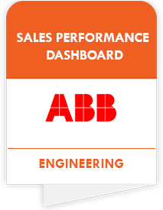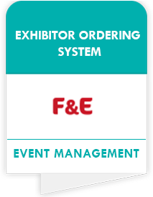

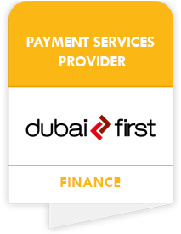



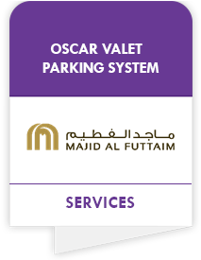

We look forward to hearing from you soon and hope that you will give us the privilege to work with you in meeting your business goals. Thank you.

Thank You



©   
1999 - 2018. All Rights Reserved   
Verbanet Technologies LLC  
www.verbat.com